1.Total Revenue
select sum(total_price) As total_Revenue from pizza
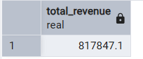

2.Avg of Order value
select sum(total_price)/count(distinct order_id ) As Avg_of_Order_Value from pizza
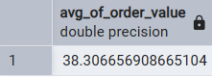

3.Total pizza sold
select sum(quantity) as Total_Piza_Sold from pizza
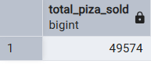

4.Total Order
select count(distinct order_id ) As total_Order from pizza
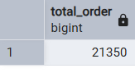

5.Avg Pizza Per Order
select CAST(CAST(sum(quantity) as decimal(10,2))/cast(count(distinct order_id)as decimal(10,2)) as decimal(10,2)) as AVG_PIZA_PER_ORDER from pizza
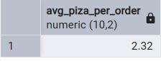
6.Daily trend for total order
select TO_CHAR(order_date,'day') as ORDER_ON,count(distinct order_id) as TOTAL_ORDER from piza group by TO_CHAR(order_date,'day')
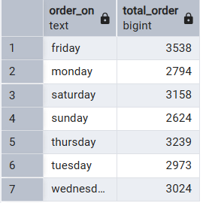

7.Hourly trend for total order
select extract(hour from order_time) as ORDER_IN_HOUR,count(distinct order_id) as TOTAL_ORDER from piza group by extract(hour from order_time)
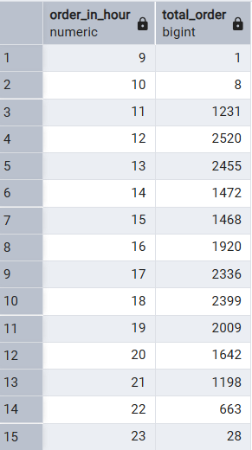

8. % of sales by pizza categories
select pizza_category,sum(total_price) as TOTAL_SALES,sum(total_price)*100/(select sum(total_price) from piza)as PCT from piza group by pizza_category
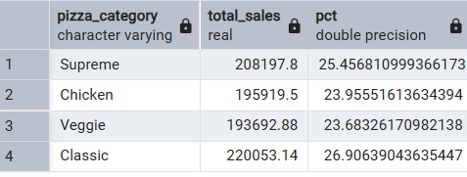

9. % of sale by pizza size
select pizza_size,CAST(sum(total_price)as decimal(10,2)) as total_sale,cast(sum(total_price)*100/(select sum(total_price) from piza ) as decimal(10,2)) as PCT from piza group by pizza_size order by PCT desc
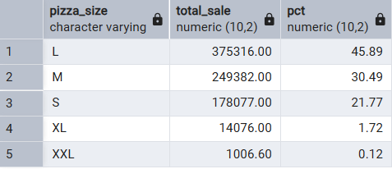

10. Total Pizza Sold By Pizza Catagorey
select pizza_category,sum(quantity ) as TOTAL_PIZZA_SOLD from piza group by pizza_category
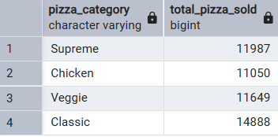

11. Top 5 Best Seller By Total pizza sold
select pizza_name,sum(quantity) as Best_Seller from piza group by pizza_name order by sum(quantity) desc limit 5
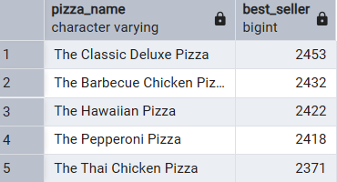

12.Bottom 5 worst seller by total pizza sold
select pizza_name,sum(quantity) as Worst_Seller from piza group by pizza_name order by sum(quantity) asc limit 5
